Tashkent – Samarkand – Bukhara – Chimgan Mountains

Duration of the program – 7 days / 6 nights
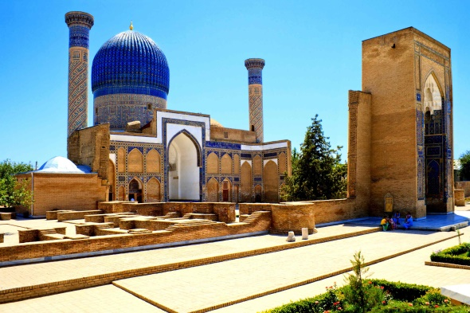
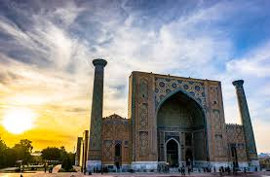
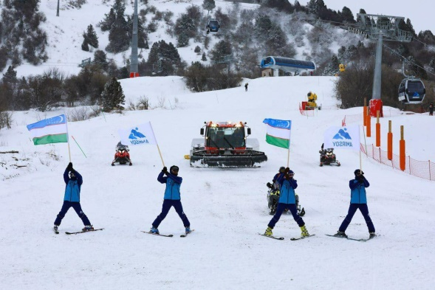

Day 1: Arrival to Tashkent
- Arrival to Tashkent
- Warm welcome at the airport
- Transfer to the hotel
- Time at leisure
- Overnight in Tashkent
Day 2: Tashkent – City Tour
- Breakfast in the hotel
- 10:00-13:00 Start the tour in Tashkent: photo-stop at Independence Square, excursion over Amir Temur Statue and local “Broadway”, Tashkent TV Tower (from outside), New Minor Mosque, Tashkent Metro ride.
- 13:30 Lunch at local city restaurant
- Afternoon is free on your own. On request, the bus may drop you for shopping at CHORSU national bazaar (for dried fruits, nuts, sweets, national clothing, and souvenirs) or SAMARKAND DARVAZA trading mall (multi-brand store).
- Overnight in Tashkent

Day 3: Tashkent – Samarkand
- Breakfast in the hotel
- 07:00 Transfer to Tashkent Railway Station.
- 08:00-10:10 High-speed train from Tashkent to Samarkand.
- On arrival, meet your driver at the station and transfer to the city center to start the excursion in Samarkand: Guri Emir Mausoleum – graveyard of Amir Temur and his generation, visit to the famous Registan Square consisting of Ulugbek Madrasah, Sherdor Madrasah and Tillya-Kori Madrasah.
- 13:30 Lunch at local city restaurant.
- Transfer to the hotel. Check-in (from 14:00) and time for rest.
- Afternoon is free to spend on you own. You may spend your time in shopping at Siyob national bazaar where you may find plenty of fresh and dried fruits, nuts, local souvenirs, sweets and variety of national bread.
- Overnight in Samarkand
Day 4: Samarkand – Bukhara
- Breakfast in the hotel
- 09:00 Transfer to Samarkand Railway Station.
- 09:50-11:19 High-speed train from Samarkand to Bukhara.
- On arrival, meet your driver at the station and transfer to the city center to start the excursion within Bukhara: Samanids Mausoleum, Bolo-Khauz Mosque, Ark Citadel – city in the city.
- 13:00 Lunch at local city restaurant.
- 14:00-17:00 Afternoon continue the tour by visiting to Poyi Kalon Architectural Ensemble that consists of Kalon Minaret, Kalon Mosque and Miri Arab Madrasah, Lyabi Khauz Complex.
- Further you may walk along the three Trading Domes, more famous as Coumpol Bazaar being existed here from the times of the Great Silk Road where you may enjoy time in shopping.
- Transfer to the hotel. Check-in and time for rest.
- Overnight in Bukhara

Day 5: Bukhara – Tashkent
- Breakfast in the hotel
- Morning is free to spend on your own.
- Check-out from the hotel till 12:00.
- 14:30 Transfer to Bukhara Railway Station.
- 15:50-19:44 High-speed train from Bukhara to Tashkent.
- On arrival, meet your driver at the station and transfer to the hotel. Check-in and time for rest.
- Overnight in Tashkent

Day 6: Tashkent – Chimgan Mountains – Amirsoy – Tashkent
- Breakfast in the hotel
- 10:00 Time to enjoy shopping tour: visit to ALAY grocery bazaar.
- 12:00 Drive towards Chimgan Mountains which is located at an altitude of 1600 meters above sea level (65 km, 1.5 hrs.).
- On arrival, transfer to Brand New Amirsoy Mountain Resort.
- 14:00 Lunch at resort’ restaurant.
- Further time to enjoy chair-cable car lift (included) to reach on the top of the mountain (cable car length is 2193 meters). Time for photo shooting and nature view.
- Take chair-cable car to come down. You may enjoy winter activities like: skiing, tubing and sledges, snowmobiling, snowshoeing, riding on quad-bikes (at your own cost).
- 17:00 Drive back to Tashkent. Transfer to the hotel.
- 19:00 Free time that you may spend in walking along the city streets in lights and have dinner at one of the restaurants.
- Overnight in Tashkent

Day 7: Departure from Tashkent
- Breakfast in the hotel
- Check out from hotel at 12 noon
- Free time before departure
- Transfer to the airport and farewell to Uzbekistan

Inclusions
- 6 nights’ accommodation in the hotel including breakfast
- 4 Lunches at local restaurants as per program
- Airport chauffeurs
- Transportation through the tour route in the comfortable car/van
- Sightseeing tours with English speaking guide
- High-speed train economy-class tickets for TAS-SKD, SKD-BHK and BHK-TAS routes
- Entrance fees for all the above mentioned monuments (except photo and video charges)
- Chair cable-car lift fees and ecological fees at the mountains
- Travel kit (sanitizers, masks, gloves on request)

Optional
- Early check in to the hotel
- Late check out from the hotel
- PCR test on departure 23 USD p/p

Exclusions
- Flight tickets
- Visa costs and processing (UAE passport holders and a person with an active UAE residence visa doesn’t need entry visa to Uzbekistan for a stay up to 30 days)
- Meals which are not mentioned in the program
- Tips and personal expenses

Price per person based on below accommodation (December, January, February):
Grand Capital 3* (city center) | 1 adult – single room: 690 USD
 | 2 adults – double/twin room: 604 USD
 | 3 adults – triple room: 564 USD
 | 4 adults – family room: 486 USD
Courtyard by Marriott 4* (city center) | 1 adult – single room: 858 USD
 | 2 adults – double/twin room: 679 USD
 | 3 adults – triple room: 634 USD
 | 4 adults – 2 connecting rooms: 561 USD
Hyatt Regency Tashkent 5* (city center) | 1 adult – single room: 888 USD
 | 2 adults – double/twin room: 695 USD
 | 3 adults – triple room: 649 USD
 | 4 adults – family room: 577 USD

