Tbilisi – Ananuri – Gudauri – Kazbegi

Duration of the program – 4 days / 3 nights

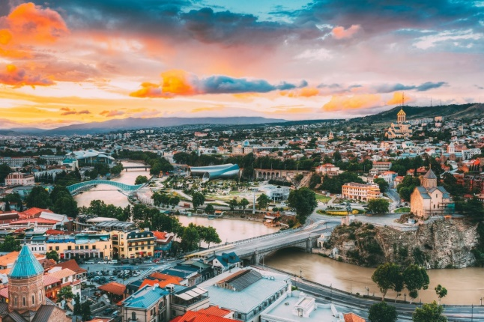
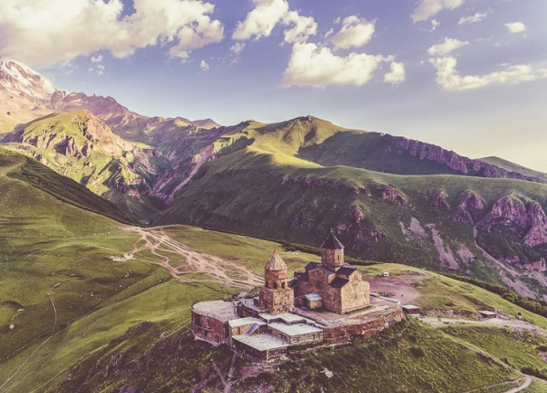
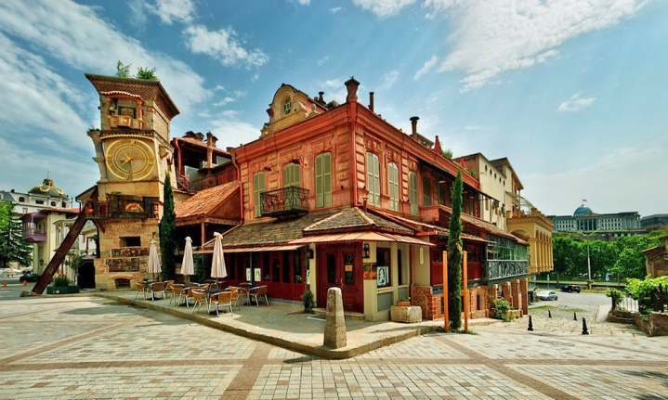

Day 1: Arrival to Tbilisi, Georgia
- Arrival to Tbilisi
- Warm welcome at the airport, transfer to the hotel
- Free time
- Overnight in Tbilisi
Day 2: Tbilisi City Tour, Mtatsminda park and relax on Lisi Lake
- Breakfast in the hotel
- 10:00 starting the tour
- It is time to explore Tbilisi city tour, visiting main attractions of the city:
- Metekhi plateau with the view of Old Town
- Rike park and Bridge of Peace (The glass bridge)
- Narikala Fortress – the main landmark of Tbilisi, ancient fort defending city and opening breathtaking views of the capital
- Abanotubani (baths district) – the oldest district of the capital where it’s history starts from
- Leghvtakhevi waterfall – beautiful nature wonder in the heart old city
- Mtastminda Park, or also known as Bombora Park is a place above Tbilisi, on a hill. Mtatsminda Park is a place where you can hang out with your friends, family or, even just by yourself. You can see whole Tbilisi from above there. There are drop down ball, horror house, small carousels, small cars to drive, falling into the water with boats, shooting games.
- Drive to Lisi Lake. It is a popular recreational area in Tbilisi. Some will find a lazy walk around lake while others will enjoy a mountain biking here. Lisi lake is perfect place for relaxation with different activities for your kids.
- Tour will be finished around 17:00
- Overnight in Tbilisi
Day 3: Tbilisi – The Caucasus Mountains - Tbilisi
- Breakfast in the hotel
- 10:00 starting the tour
- Today we have exciting journey to the mountain areas of Georgia via Georgian Military Highway through the Caucasus Mountains.
- Ananuri – medieval fortress overlooking the Jinvali Reservoir. Beautiful place at any time of the year.
- Pasanauri – the settlement famous for khinkali and the confluence of Black and White Aragvi rivers.
- Gudauri - the largest and highest ski resort in Georgia along the Georgian Military Highway at an elevation of 2,200 meters (7,200 ft.) above sea level. But it is famous even during other seasons. People come here to enjoy breathtaking views, breath in fresh air and paraglide!
- Return back to Tbilisi around evening time
- Overnight in Tbilisi

Day 4: Departure from Tbilisi
- Breakfast in the hotel
- Check out from hotel
- Free time before departure
- Transfer to the airport and farewell to Georgia

Inclusions
- 3 nights’ accommodation in the hotel including breakfast
- Private Airport chauffeurs
- Private transportation through the tour route in the comfortable car
- Private sightseeing tours with English speaking driver-guide
- Local sim card
- Honeymoon amenities set up upon arrival
- Private jeep in Kazbegi

Optional
- Lunches / Dinners
- Early check in to the hotel
- Late check out from the hotel
- Travel insurance

Exclusions
- Flight tickets
- Tips
- Visa charges (if required)

Price per person based on below accommodation (price valid till 31 August 2020)
Iveria Inn 4* (park view) | 190 USD
Sole Palace 4* (city view with balcony) | 209 USD
Brim Hotel 4* (city view with balcony) | 201 USD
Hotels and Preferences 5* (park view) | 242 USD

*Please note hotels remain subject to availability at the time of booking

