Tashkent – Chimgan Mountains

Duration of the program – 4 days / 3 nights
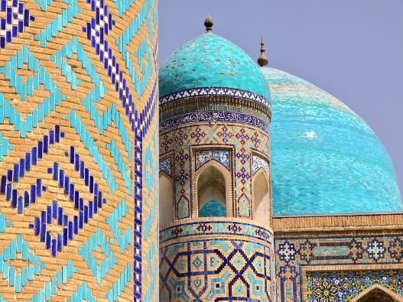
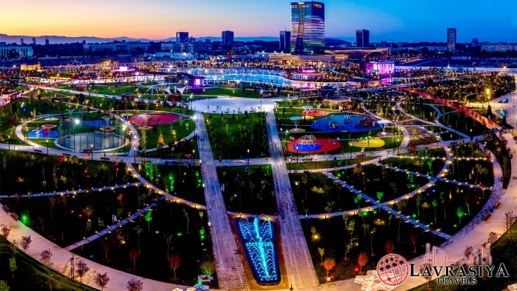
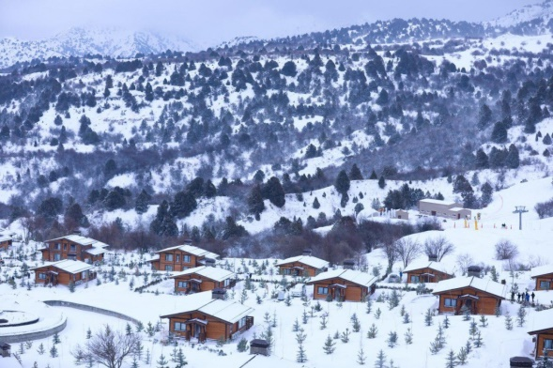

Day 1: Arrival to Tashkent
- Arrival to Tashkent
- Warm welcome at the airport
- Transfer to the hotel
- Time at leisure
- Overnight in Tashkent
Day 2: Tashkent – City Tour
- Breakfast in the hotel
- 10:00-13:00 Start the tour in Tashkent: photo-stop at Independence Square, excursion over Amir Temur Statue and local “Broadway”, Tashkent TV Tower (from outside), New Minor Mosque, Tashkent Metro ride.
- 13:30 Lunch at local city restaurant
- Afternoon is free on your own. On request, the bus may drop you for shopping at CHORSU national bazaar (for dried fruits, nuts, sweets, national clothing, and souvenirs) or SAMARKAND DARVAZA trading mall (multi-brand store).
- Overnight in Tashkent

Day 3: Tashkent – Chimgan Mountains – Amirsoy – Tashkent
- Breakfast in the hotel
- 10:00 Time to enjoy shopping tour: visit to ALAY grocery bazaar.
- 12:00 Drive towards Chimgan Mountains which is located at an altitude of 1600 meters above sea level (65 km, 1.5 hrs.).
- On arrival, transfer to Brand New Amirsoy Mountain Resort.
- 14:00 Lunch at resort’ restaurant.
- Further time to enjoy chair-cable car lift (included) to reach on the top of the mountain (cable car length is 2193 meters). Time for photo shooting and nature view.
- Take chair-cable car to come down. You may enjoy winter activities like: skiing, tubing and sledges, snowmobiling, snowshoeing, riding on quad-bikes (at your own cost).
- 17:00 Drive back to Tashkent. Transfer to the hotel.
- 19:00 Free time that you may spend in walking along the city streets in lights and have dinner at one of the restaurants.
- Overnight in Tashkent
Day 4: Departure from Tashkent
- Breakfast in the hotel
- Check out from hotel at 12 noon
- Free time before departure
- Transfer to the airport and farewell to Uzbekistan

Inclusions
- 3 nights’ accommodation in the hotel including breakfast in Tashkent
- 2 Lunches at local restaurants as per program
- Airport chauffeurs
- Transportation through the tour route in the comfortable car/van
- Sightseeing tours with English speaking guide
- Entrance fees for all the above mentioned monuments (except photo and video charges)
- Chair cable-car lift fees and ecological fees at the mountains
- Travel kit (sanitizers, masks, gloves on request)

Optional
- Early check in to the hotel
- Late check out from the hotel
- PCR test on departure 23 USD p/p

Exclusions
- Flight tickets
- Visa costs and processing (UAE passport holders and a person with an active UAE residence visa doesn’t need entry visa to Uzbekistan for a stay up to 30 days)
- Meals which are not mentioned in the program
- Tips and personal expenses

Price per person based on below accommodation (December, January, February):
Grand Capital 3* (city center) | 1 adult – single room: 310 USD
 | 2 adults – double/twin room: 255 USD
 | 3 adults – triple room: 240 USD
 | 4 adults – family room: 207 USD
Courtyard by Marriott 4* (city center) | 1 adult – single room: 450 USD
 | 2 adults – double/twin room: 307 USD
 | 3 adults – triple room: 285 USD
 | 4 adults – 2 connecting rooms: 280 USD
Hyatt Regency Tashkent 5* (city center) | 1 adult – single room: 440 USD
 | 2 adults – double/twin room: 320 USD
 | 3 adults – triple room: 300 USD
 | 4 adults – family room: 275 USD

